Geraldton Senior High School
ATMAM Math Methods
Random Samples and Sampling Distributions

Name: __________________________

Total: 50 marks

Instructions:

This investigation is an individual, take home task of 1 week in duration.

This investigative task is Due: _____________________

By ticking this box, I am verifying that the work that is submitted is my own.

Signed: ___________________________ Date: ____________________

Question 1 (5, 5, 6 = 16 marks)

A random sampling experiment is being simulated on a CAS calculator to investigate the impact on sample size versus repeated sampling in terms of the convergence of the experimental mean and standard deviation to the population mean and estimated standard deviation according to $σ_{\hat{p}}≈\sqrt{\frac{σ^{2}}{n}}$, where $σ$ is the population standard deviation.

- The code below has been entered into a CAS calculator. Enter this code into your calculator and give a brief explanation of each line of code, including why the cursor needs to be placed in the second line to create the data for the next experiment.

For next experiment place cursor| here then EXE

After 5 experiments

Use your CAS calculator to run 5 experiments, it will show results similar to those shown below.

- For the table below, explain what is shown in each column and in each row, including an explanation as to why list2 has a different number of rows to the other lists.

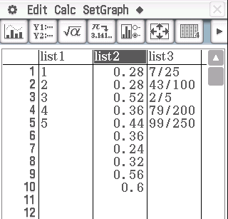
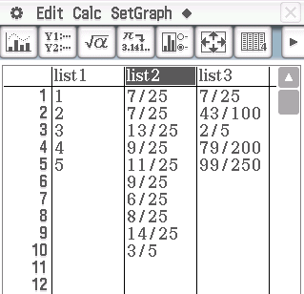
If your Classpad gives you fractional outputs in any of the lists, select the list by tapping in the list heading cell, eg. list2, and then tap the
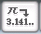 button.

- Use the instructions on the following page to draw labelled graphs of your results on the axes below, that include:
- a histogram and boxplot of the on the left axes,
- on the right axes draw line graphs of the experimental mean and standard deviation and theoretical estimate for the standard deviation.

Comment on your results.
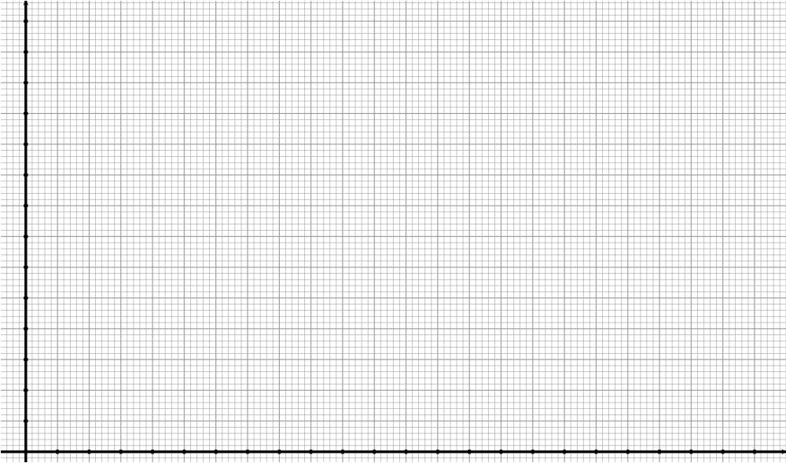

Comment on your results.

To create graphs to analyse your data follow the steps below.

For histogram with box-plot:
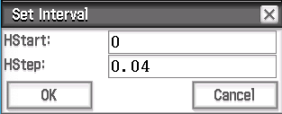

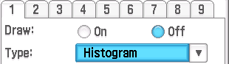
For list graph of mean and standard deviation:
Turn off Set StatGraphs 1 and 2 first.
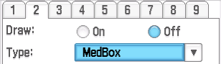
Question 2 (on page 8) (6 marks)

$randBin(5n, 0.4,10)$ Increasing sample size with fixed 10 sample repeats performed.

After 10 Experiments $(n=1→10)$

Shown below are simulated results for an increasing sample size of $5n$, i.e., $5→50$, each with 10 sample repeats.
Distribution of the mean of the
sample proportions. Progressive means
(10 samples of size 50 each)

Progressive standard deviations

After 25 Experiments $(n=1→25)$

Shown below are simulated results for an increasing sample size of $5n$, i.e., $5→125$, each with 10 sample repeats.
Distribution of the mean of the
sample proportions. Progressive means
(10 samples of size 125 each)

Progressive standard deviations

After 50 Experiments $(n=1→50)$

Use your calculator to complete 50 experiments.

Options – draw by hand, glue screenshots in place, or complete the investigation in MS Word.
NB: if hand drawn, just use the last 25 data points.

- Draw a histogram and boxplot graph of the distribution of the mean of the sample proportions.

- Draw a line graph of the progressive means.

- Draw a line graph of the progressive standard deviations.

Question 3 (on page 11) (6 marks)

$randbin(10, 0.4,5n)$ Fixed sample size of 10 with increasing number of sample repeats performed.

After 10 Experiments $(n=1→10)$

Shown below are simulated results for an increasing sample repeats performed of $5n$, i.e., $5→50$, each with sample size of 10.
Distribution of the mean of the
sample proportions. Progressive means
(50 samples of size 10 each)

Progressive standard deviations

After 25 Experiments $(n=1→25)$

Shown below are simulated results for an increasing sample repeats performed of $5n$, i.e., $5→125$, each with sample size of 10.
Distribution of the mean of the
sample proportions. Progressive means
(125 samples of size 10 each)

Progressive standard deviations

After 50 Experiments $(n=1→50)$

Use your calculator to complete 50 experiments.

Options – draw by hand, glue screenshots in place, or complete the investigation in MS Word.
NB: if hand drawn, just use the last 25 data points.

- Draw a histogram and boxplot graph of the distribution of the mean of the sample proportions.

- Draw a line graph of the progressive means.

- Draw a line graph of the progressive standard deviations.

Question 4 (8 marks)
Comment on your results from Question 2 and Question 3 regards larger sample sizes and fewer repeats versus smaller sample sizes and a large number of repeats.

Question 5 (14 marks)
For a variety of distributions (including normal and uniform distributions), use the Online Stat Book interactive tool to investigate the distribution of sample means as the sample size increases. Link below:
https://onlinestatbook.com/stat_sim/sampling_dist/index.html
Use statistics and graphs to communicate your results.

